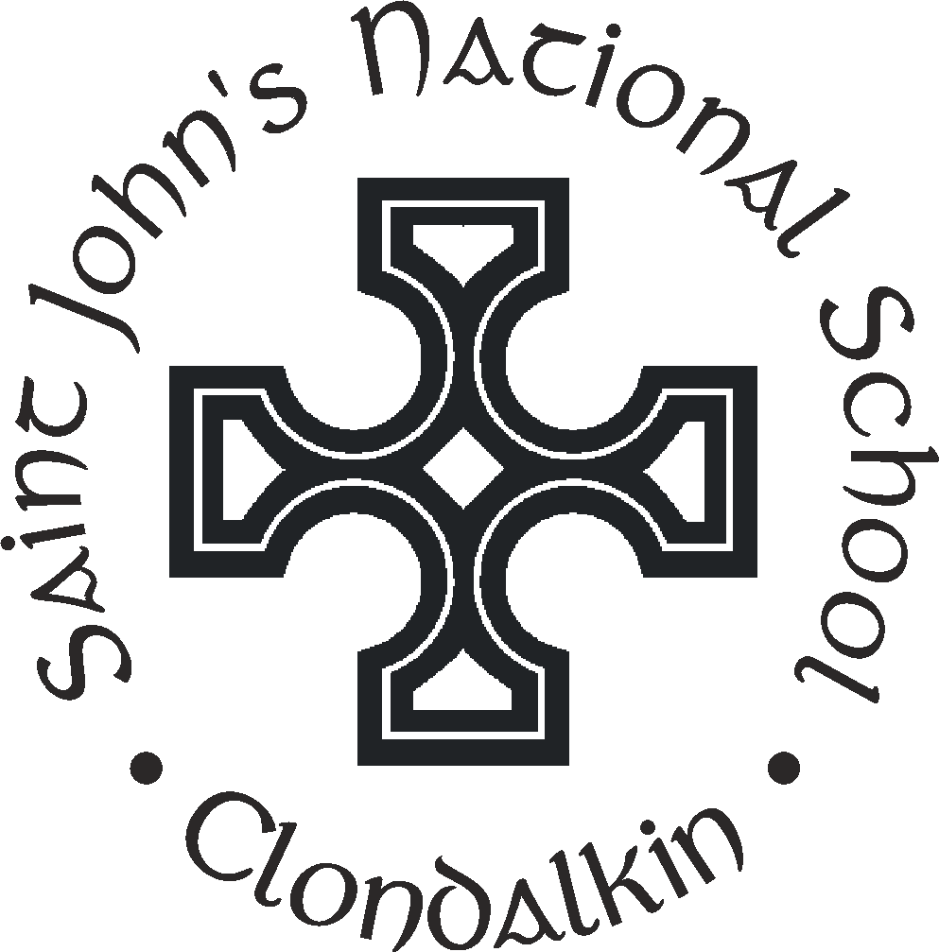
St John’s (Church of Ireland) National School
Tower Road, Clondalkin, Dublin 22.
Roll No. 18642Q
Tel. 01 4570680
E-mail. secretary@stjohnsnsclondalkin.com

ADMISSIONS POLICY

School Patron: Church of Ireland Archbishop of Dublin and Bishop of Glendalough

Introduction

This Admission Policy complies with the requirements of the Education Act 1998, the Education (Admission to Schools) Act 2018 and the Equal Status Act 2000. In drafting this policy, the board of management of the school has consulted with school staff, the school patron and with parents of children attending the school.

The policy was approved by the school patron on 15th December 2022. It is published on the school’s website and will be made available in hardcopy, on request, to any person who requests it.

The relevant dates and timelines for St. John’s N.S. admission process are set out in the school’s annual admission notice which is published annually on the school’s website at least one week before the commencement of the admission process for the school year concerned.
This policy must be read in conjunction with the annual admission notice for the school year concerned.
The application form for admission is published on the school’s website and will be made available in hardcopy on request to any person who requests it.

Characteristic spirit and general objectives of the school

St. John’s N.S. is a co-education primary school under Church of Ireland management. The Archbishop of Dublin and Bishop of Glendalough is the school’s Patron. The school endeavours to promote the moral, spiritual, emotional, intellectual, physical and social development of all the pupils in its care. The school reflects the ethos of the Church of and values of honesty, charity, kindness, patience and personal responsibility are encouraged. Equally it encourages and practises respect for the traditions and teachings of other churches and spiritual communities. The teaching of Religious Education in this school does not involve religious formation or specifically confessional teaching as this is a matter for each family and their Church. The constitutional right of parents to withdraw their child from Religious Education is acknowledged. However the attention of parents is drawn to the fact that due to accommodation constraints and the limited availability of staff a child who is withdrawn from RE may have to be remain in the classroom for the duration of the lesson.
Children of other faiths and none are welcomed and affirmed.

St. John’s N.S. is a community where all pupils are equally valued and respected – irrespective of gender, social or ethnic background, family circumstances, educational achievement, physical characteristics or intellectual capacity.

St. John’s N.S. is a community where the traditions and teaching of the Church of Ireland inform the position taken in regard to moral issues which arise in the teaching of secular subjects.

The work of the school is conducted in an atmosphere of inclusion, tolerance and respect for religious differences. The admission policy of the school allows those of other faiths or none to enrol as pupils. St. John’s N.S. values and recognises the contribution that pupils of different faiths bring to the life of the school.

St. John’s N.S. is a part of the local church community and has links with the Parish. Pupils take part in services in the local church (eg. Advent, Easter etc.) Special events take place in the school to mark religious festivals and celebrations eg. Christmas, Harvest etc. The Rector visits the school and takes part in Assembly on a regular basis.

Time spent teaching Religious Education is per Department of Education guidelines. All pupils generally take part in Religious Education lessons. The ‘Follow Me’ programme (developed by the Church of Ireland, Methodist and Presbyterian Boards of Education) is in used throughout all the classes. Please see the Religious Education Policy for further details.

In accordance with S.15 (2) (b) of the Education Act, 1998 the Board of Management of St. John’s N.S. shall uphold, and be accountable to the patron for so upholding, the characteristic spirit of the school as determined by the cultural, educational, moral, religious, social, linguistic and spiritual values and traditions which inform and are characteristic of the objectives and conduct of the school.

Admission Statement

St. John’s N.S. will not discriminate in its admission of a student to the school on any of the following:

- the gender ground of the student or the applicant in respect of the student concerned,
- the civil status ground of the student or the applicant in respect of the student concerned,
- the family status ground of the student or the applicant in respect of the student concerned,
- the sexual orientation ground of the student or the applicant in respect of the student concerned,
- the religion ground of the student or the applicant in respect of the student concerned,
- the disability ground of the student or the applicant in respect of the student concerned,
- the ground of race of the student or the applicant in respect of the student concerned,
- the Traveller community ground of the student or the applicant in respect of the student concerned, or
- the ground that the student or the applicant in respect of the student concerned has special educational needs

As per section 61 (3) of the Education Act 1998, ‘civil status ground’, ‘disability ground’, ‘discriminate’, ‘family status ground’, ‘gender ground’, ‘ground of race’, ‘religion ground’, ‘sexual orientation ground’ and ‘Traveller community ground’ shall be construed in accordance with section 3 of the Equal Status Act 2000.

St. John’s N.S. will cooperate with the National Council for Special Education in the performance by the Council of its functions under the Education for Persons with Special Educational Needs Act 2004 relating to the provision of education to children with special educational needs, including in particular by the provision and operation of a special class or classes when requested to do so by the Council.

St. John’s N.S. will comply with any direction served on the patron or the board, as the case may be, under section 37A and any direction served on the board under section 67(4B) of the Education Act.

St. John’s N.S. is a school whose objective is to provide education in an environment which promotes certain religious values and does not discriminate in relation to the admission of a student who has applied for a place in the school in accordance with section 7A of the Equal Status Act 2000.
St. John’s NS is a school whose objective is to provide education in an environment which promotes certain religious values and does not discriminate where it refuses to admit as a student a person who is not Church of Ireland and it is proved that the refusal is essential to maintain the ethos of the school.

Admission of Students

This school shall admit each student seeking admission except where –

- the school is oversubscribed (please see section 5 below for further details)
- a parent of a student, when required by the principal in accordance with section 23(4) of the Education (Welfare) Act 2000, fails to confirm in writing that the code of behaviour of the school is acceptable to him or her and that he or she shall make all reasonable efforts to ensure compliance with such code by the student

St. John’s N.S. is a Church of Ireland school and may refuse to admit as a student a person who is not of the Protestant faith where it is proved that the refusal is essential to maintain the ethos of the school.

Oversubscription

In the event that the school is oversubscribed, the school will, when deciding on applications for admission, apply the following selection criteria in the order listed below to those applications that are received within the timeline for receipt of applications as set out in the school’s annual admission notice:

- Priority Category 1:
An Applicant Student who is a member of the Church of Ireland or a Protestant reformed church or is a member of a minority religion which has the same religious ethos, or a similar religious ethos to the programme of religious instruction/education which is provided in the school and who lives within the boundary of The Clondalkin and Rathcoole Parish.
- Priority Category 2:
. An Applicant Student who is a sibling of a student currently attending the school.
- Priority Category 3:
An Applicant Student who is a member of the Church of Ireland, or a Protestant reformed church or is a member of a minority religion which has the same religious ethos, or a similar religious ethos to the programme of religious instruction/education which is provided in the school and who lives within a 10km radius of the school.
- Priority Category 4:
All other Applicant Students who comply with the terms of this Policy.

In respect of Priority categories 1 and 2 above, the Applicant must provide the following documentation with the application form in order for the application to be complete, as the School must satisfy itself that the Applicant Student is a member of a minority religion and that it provides a programme of religious instruction or religious education which is of the same religious ethos as, or a similar religious ethos to, the religious ethos of the minority religion of the Applicant Student.

(i) a statement from the Applicant confirming (i) that the Applicant Student is a member of a minority religion and (ii) that the Applicant wishes the Applicant Student to be educated in a school that provides a programme of religious instruction/education which is of the same religious ethos, or a similar religious ethos to, the religious ethos of the minority religion of the Applicant Student.

and

(ii) evidence from the Applicant to support the statement that the Applicant Student is a member of the minority religion. This evidence will consist of:

- a letter from the relevant religious leader confirming, that the Applicant Student is a member of the minority religion or

- the signature and stamp of the relevant Church leader on the application form confirming, that the Applicant Student is a member of the minority religion or

- a baptismal record issued by the relevant minority religion which confirms that the Applicant Student has been baptised as a member of the minority religion

In the event that there are two or more students tied for a place or places in any of the selection criteria categories above (the number of applicants exceeds the number of remaining places), the following arrangements will apply:

It is to be noted that where oversubscription occurs in any one of the above priority categories a lottery system will be conducted by the Chairperson, Principal and one independent party.

What will not be considered or taken into account

In accordance with section 62(7) (e) of the Education Act, the school will not consider or take into account any of the following in deciding on applications for admission or when placing a student on a waiting list for admission to the school:

- a student’s prior attendance at a pre-school or pre-school service, including naíonraí,

- the payment of fees or contributions (howsoever described) to the school;

- a student’s academic ability, skills or aptitude;

- the occupation, financial status, academic ability, skills or aptitude of a student’s parents;

- a requirement that a student, or his or her parents, attend an interview, open day or other meeting as a condition of admission;

- a student’s connection to the school by virtue of a member of his or her family attending or having previously attended the school;
other than siblings of a student attending the school as set out in Section 5.

- the date and time on which an application for admission was received by the school.

This is subject to the application being received at any time during the period specified for receiving applications set out in the annual admission notice of the school for the school year concerned.

Decisions on applications

All decisions on applications for admission to St. John’s N.S. will be based on the following:
- Our school’s admission policy
- The school’s annual admission notice (where applicable)
- The information provided by the applicant in the school’s official application form received during the period specified in our annual admission notice for receiving applications

(Please see section 13 below in relation to applications received outside of the admissions period and section 14 below in relation to applications for places in years other than the intake group.)

Selection criteria that are not included in our school admission policy will not be used to make a decision on an application for a place in our school.

Notifying applicants of decisions

Applicants will be informed in writing as to the decision of the school, within the timeline outlined in the annual admissions notice.

If a student is not offered a place in our school, the reasons why they were not offered a place will be communicated in writing to the applicant, including, where applicable, details of the student’s ranking against the selection criteria and details of the student’s place on the waiting list for the school year concerned.

Applicants will be informed of the right to seek a review/right of appeal of the school’s decision (see section17 below for further details).

Acceptance of an offer of a place by an applicant

In accepting an offer of admission from St. John’s N.S. you must indicate—

(i) whether or not you have accepted an offer of admission for another school or schools. If you have accepted such an offer, you must also provide details of the offer or offers concerned and

(ii) whether or not you have applied for and awaiting confirmation of an offer of admission from another school or schools, and if so, you must provide details of the other school or schools concerned.

Circumstances in which offers may not be made or may be withdrawn

An offer of admission may not be made or may be withdrawn by St. John’s N.S. where—
- it is established that information contained in the application is false or misleading.
- an applicant fails to confirm acceptance of an offer of admission on or before the date set out in the annual admission notice of the school.
- the parent of a student, when required by the principal in accordance with section 23(4) of the Education (Welfare) Act 2000, fails to confirm in writing that the code of behaviour of the school is acceptable to him or her and that he or she shall make all reasonable efforts to ensure compliance with such code by the student; or
- an applicant has failed to comply with the requirements of ‘acceptance of an offer’ as set out in section 9 above.

Sharing of Data with other schools

Applicants should be aware that section 66(6) of the Education (Admission to Schools) Act 2018 allows for the sharing of certain information between schools in order to facilitate the efficient admission of students.

Section 66(6) allows a school to provide a patron or another board of management with a list of the students in relation to whom—

(i) an application for admission to the school has been received,

(ii) an offer of admission to the school has been made, or

(iii) an offer of admission to the school has been accepted.

The list may include any or all of the following:
(i) the date on which an application for admission was received by the school;

(ii) the date on which an offer of admission was made by the school;

(iii) the date on which an offer of admission was accepted by an applicant;

(iv) a student’s personal details including his or her name, address, date of birth and personal public service number (within the meaning of section 262 of the Social Welfare Consolidation Act 2005).

Waiting list in the event of oversubscription

In the event of there being more applications to the school year concerned than places available, a waiting list of students whose applications for admission to St. John’s N.S. were unsuccessful due to the school being oversubscribed will be compiled and will remain valid for the school year in which admission is being sought.

Placement on the waiting list of St. John’s N.S. is in the order of priority assigned to the students’ applications after the school has applied the selection criteria in accordance with this admission policy.

Applicant students whose applications are received after the closing date outlined in the Annual Admission Notice, will be placed at the end of the waiting list in order of the date of receipt of the application.

Offers of any subsequent places that become available for and during the school year in relation to which admission is being sought will be made to those students on the waiting list, in accordance with the order of priority in relation to which the students have been placed on the list.

Late Applications

All applications for admission received after the closing date as outlined in the annual admission notice will be considered and decided upon in accordance with our school’s admissions policy, the Education Admissions to School Act 2018 and any regulations made under that Act.

Late applicants will be notified of the decision in respect of their application no later than three weeks after the date on which the school received the application. Applicant students will be offered a place if a place is available. In the event that there is no place available, the name of the applicant student will be added to the waiting list in accordance with section 12 of this policy.

Procedures for admission of students to other years and during the school year
The procedures of the school in relation to the admission of students who are not already admitted to the school to classes or years other than the school’s intake group are as follows:

Applicants will be notified of the decision in respect of their application no later than three weeks after the date on which the school received the application. Applicant students will be offered a place in the relevant class if a place is available. In the event that the number of applications exceeds the number of available places in the relevant class, the school will apply the selection criteria set out in of this policy to those applications. In the event that there is no place available, the name of the applicant student will be added to the waiting list in accordance with of this policy.

The procedures of the school in relation to the admission of students who are not already admitted to the school, after the commencement of the school year in which admission is sought, are as follows:

Late applicants will be notified of the decision in respect of their application no later than three weeks after the date on which the school received the application. Applicant students will be offered a place if there is a place available. In the event that there is no place available, the name of the applicant student will be added to the waiting list in accordance with Section 12 of this policy.

Declaration in relation to the non-charging of fees

The board of St. John’s N.S. or any persons acting on its behalf will not charge fees for or seek payment or contributions (howsoever described) as a condition of-
- an application for admission of a student to the school, or
- the admission or continued enrolment of a student in the school.

Arrangements regarding students not attending religious instruction

The following are the school’s arrangements for parents who have requested that the student attend the school without attending religious instruction in the school. These arrangements will not result in a reduction in the school day of such students:

A written request should be made to the Principal of the school. A meeting will then be arranged with the parent(s)/guardians of the student to discuss how the request may be accommodated by the school.

Reviews/appeals

Review of decisions by the board of Management
The parent of the student may request the board to review a decision to refuse admission. Such requests must be made in accordance with Section 29C of the Education Act 1998.
The timeline within which such a review must be requested and the other requirements applicable to such reviews are set out in the procedures determined by the Minister under section 29B of the Education Act 1998 which are published on the website of the Department of Education and Skills.
The board will conduct such reviews in accordance with the requirements of the procedures determined under Section 29B and with section 29C of the Education Act 1998.
Note: Where an applicant has been refused admission due to the school being oversubscribed, the applicant must request a review of that decision by the board of management prior to making an appeal under section 29 of the Education Act 1998.
Where an applicant has been refused admission due to a reason other than the school being oversubscribed, the applicant may request a review of that decision by the board of management prior to making an appeal under section 29 of the Education Act 1998.

Right of appeal
Under Section 29 of the Education Act 1998, the parent of the student, the student, may appeal a decision of this school to refuse admission.
An appeal may be made under Section 29 (1) (c) (i) of the Education Act 1998 where the refusal to admit was due to the school being oversubscribed.
An appeal may be made under Section 29 (1) (c) (ii) of the Education Act 1998 where the refusal to admit was due a reason other than the school being oversubscribed.
Where an applicant has been refused admission due to the school being oversubscribed, the applicant must request a review of that decision by the board of management prior to making an appeal under section 29 of the Education Act 1998. (see Review of decisions by the Board of Management)
Where an applicant has been refused admission due to a reason other than the school being oversubscribed, the applicant may request a review of that decision by the board of management prior to making an appeal under section 29 of the Education Act 1998. (see Review of decisions by the Board of Management)
Appeals under Section 29 of the Education Act 1998 will be considered and determined by an independent appeals committee appointed by the Minister for Education and Skills.
The timeline within which such an appeal must be made and the other requirements applicable to such appeals are set out in the procedures determined by the Minister under section 29B of the Education Act 1998 which are published on the website of the Department of Education and Skills.

